**Donkey Car: Pi to Standard**

To switch from using the Logitech controllers and the Raspberry Pi to the standard controller (given in the package) use the following steps:

1. Make sure the car is off (bottom battery unplugged)
2. Unplug the wires from the motor controller and plug them into the receiver near the bottom of the car as shown.

= steering cable – from channel 0 to channel 2

= throttle cable – from channel 1 to channel 1

Receiver

Motor Controller

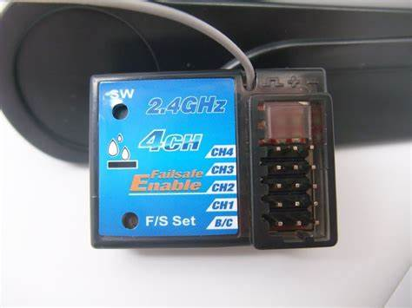

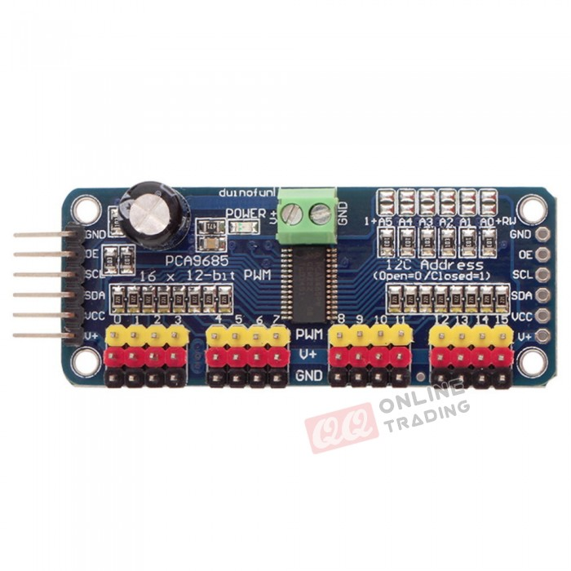

1. Plug the bottom battery pack back in and lights should come on on both the ESC and the receiver. Then take the controller for that designated car and open the top panel to access the on/off switch. Turn it on and you’re ready to go